

NAME.…………………………………………………………………Class ………………

P840/1

INFORMATION COMMUNICATION TECHNOLOGY

SENIOR TWO TIME: 1HRS

**SECTION A (30 SCORES)**

1. Given the devices in the pictures below

**E**

C

D

**B**

**A**

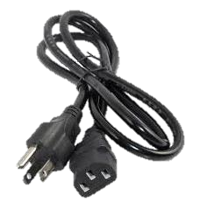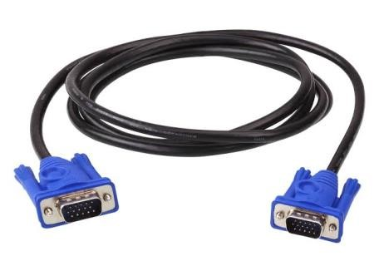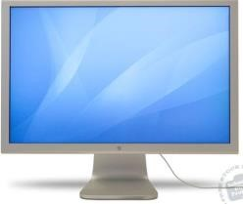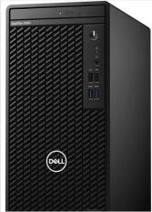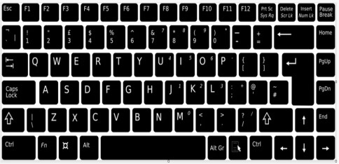

Name and explain the importance of each hardware component. (10 scores)

………………………………………………………………………………………………………………………………………………………………………………………………………………………………………………………………………………………………………………………………………………………………………………………………………………………………………………………………………………………………………………………………………………………………………………………………………………………………………………

2. Your school director wants to fully stock the computer lab by purchasing more computers.

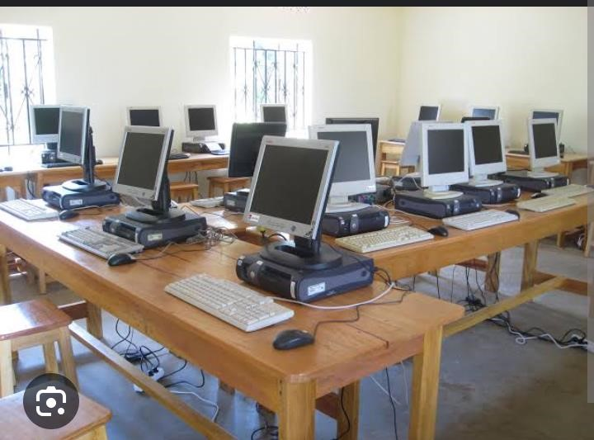

TASK:

As an ICT learner, you are required to;

a) Give guidance on how the computers can be cared for such that they work efficiently and last longer. (5 scores)

…………………………………………………………………………………………………………………………………………………………………………………………………………………………………………………………………………………………………………………………..……………………………………………………………………………………………………………….…....……………………………………………………………………………………………………………….………………………………………………………………………………………………………..……………………………………………………………………………………………………………………..…

b) Give five health problems caused by prolonged use of computers. (5scores)

…………………………………………………………………………………………………………………………………………………………………………………………………………………………………………………………………………………………………………………………..……………………………………………………………………………………………………………….…....……………………………………………………………………………………………………………….………………………………………………………………………………………………………..……………………………………………………………………………………………………………………..…

**3.**  Mbabazi Ketra wants to edit her document, she goes to an internet café downloads it from Google drive and opens it. The computer in the café has a key board that is different from that of Mbabazi Ketra’s home computer. The key board has symbols shown in the diagram below. Help Mbabazi Ketra identify the keys and their functions labeled below. (10 scores)

**A**

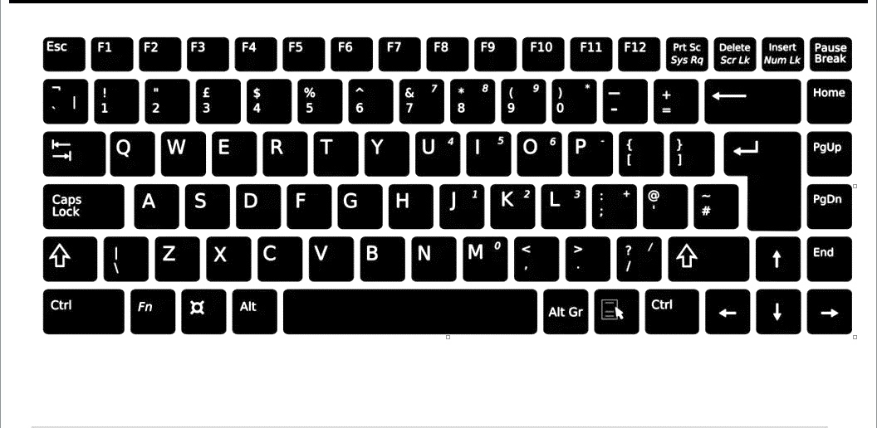

**E**

**C**

**B**

**D**

………………………………………………………………………………………………………………………………………………………………………………………………………………………………………………………………………………………………………………………………………………………………………………………………………………………………………………………………………………………………………………………………………………………………………………………………………………………………………………

………………………………………………………………………………………………………………………………………………………………………………………………………………………………………………………………………………………………………………………………………………………………………………………………………………………………………………………………………………………………………………………………………